Hello! Here are some common questions and answers for new and existing Parents at Palmer Park Prep:

**Administration** **1**

**Important Numbers** **2**

**Uniforms** **2**

**School Information** **3**

I Ready: 3

Helpful Home Routines: 3

Communication: 4

**School entrances and hours** **4**

**Before/After Care** **5**

**Lunch** **5**

**Volunteering** **6**

**Meeting Glossary** **9**

**Montessori Specific Details** **11**

​​Birthdays: 11

Work Time: 11

Cubbies/Lockers: 12

School Shoes: 12

Outdoor Time: 12

First day/week things needed: 12

Pre-K/K specifics 13

# Administration

**Principal**: Christa Reeves ([christa.reeves@detroitk12.org](mailto:christa.reeves@detroitk12.org)) 313-494-7130

**Assistant Principal:** Kamiliah Teasley ([kamilah.teasley@detroitk12.org](mailto:kamilah.teasley@detroitk12.org) )

**Dean of Culture:** Willie Jenkins ([Willie.Jenkins@detroitk12.org](mailto:Willie.Jenkins@detroitk12.org))

**School Counselor:** Kim McQueen ([kim.mcqueen@detroitk12.org](mailto:kim.mcqueen@detroitk12.org))

[Full staff list with contact info here](https://www.detroitk12.org/Page/3564)

**School Nurse**: Nurse Allen 313-494-9311

**Parent Outreach Coorindator:**  Amber Hunt ([amber.hunt@detroitk12.org](mailto:amber.hunt@detroitk12.org)) 517-303-3896

# Important Numbers

**School bus transportation:** 313-945-8600

**Field trip bus transportation**: 313-835-2700 (ABC Student Transportation) 313-895-1300 (DHT Transportation)

# Uniforms

**Pre-K through 8th grade uniforms:**

**Tops**

Pre-k-8th grade Montessori: Yellow Shirts

5th grade - Hunter green

6th grade: Navy Blue Shirts

7th grade: Maroon Shirts

8th grade: Black Shirts

**Bottoms**

o Khaki

o Brown

o Black

The **only** jackets/sweaters allowed in school must be **brown** or **black**. Hoodies will not be accepted.

Shorts, skirts, jumpers are all ok in the approved uniform colors.

White polos have also been acceptable in years past for Montessori.

**Where to buy Uniforms:**

**For Kids only (9 mile & Coolidge) -** From a parent “They carry a great selection of uniforms all year round. They also have a lay a way program. It's also a great place for boys uniform pants because they have reinforced knee.”

[Target](https://www.target.com/c/school-uniforms-kids/-/N-5tg6q)

[Old Navy](https://oldnavy.gap.com/products/school-uniforms.jsp)

[Amazon](https://www.amazon.com/s?k=kids+school+uniform+clothes&gclid=Cj0KCQjwg7KJBhDyARIsAHrAXaH49nTr5XYnGKTaVH6dJkTb4cXV0BjNzSK5z6CtCgp3_6z-5Lo1Jn8aAtGAEALw_wcB&hvadid=409942375800&hvdev=c&hvlocphy=9016940&hvnetw=g&hvqmt=b&hvrand=2352128266553527948&hvtargid=kwd-309281193799&hydadcr=14066_11131645&tag=googhydr-20&ref=pd_sl_5u05t174cy_b)

[Carters](https://www.carters.com/carters-uniform)

[JC Penny](https://www.jcpenney.com/g/shops/school-uniforms)

Kids for Less (25493 Grand River Ave, Redford Charter Twp, MI 48240)

[Children’s Place](https://www.childrensplace.com/us/search/uniforms)

[Rainbow Junior](https://www.rainbowshops.com/collections/school-uniforms)

[Kohl’s](https://www.kohls.com/catalog/school-uniform-kids-clothing.jsp)

# School Information

Address: 3901 Margareta Ave, Detroit, MI 48221

Phone: [(313) 494-7300](https://www.google.com/search?q=palmer+park+prep+dpscd&oq=palmer+p&aqs=chrome.0.69i59j69i57j35i39j0j46l2j69i61l2.1214j0j4&sourceid=chrome&ie=UTF-8#)

Website: [https://www.detroitk12.org/palmerpark](https://www.detroitk12.org/palmerpark?fbclid=IwAR3zdESiRZIVp0yL5vQIJlQonEAqliLbE9Ls6h4ffhZKfD7AyH_zUDyWzAc)

Facebook group: <https://www.facebook.com/groups/parentsofP3A/>

Twitter: @AcademyPalmer

Palmer Park Prep offers Montessori for Pre-K through 7th grade, and Traditional curriculum for 5th - 8th grade. The current vision to to transition to a wall-to-wall Montessori school over the next 3 years, eliminating a traditional grade each year until only Montessori instruction is provided throughout the school

## I Ready:

* I Ready is a district program providing individualized math and reading online lessons.
* All K-8 grade students (including Montessori) in DPSCD participate daily in I Ready.

## Helpful Home Routines:

* Check and empty backpacks daily
* Read with your child daily
* Set an early bedtime for plenty of rest
* Talk about their day together

## Communication:

* Teachers use the ClassDojo app to communicate and share photos. This is a free app. A link will be provided to sign up during the first weeks of school.
* Monthly printed newsletters are sent home
* Robocalls are a key way to receive school and district information. Please make sure the front desk has your most up to date contact info and do not opt out of robocalls.

# School entrances and hours

**Entry and Dismissal Procedures:**​

* Montessori students (PreK/K) enter and depart through Door #13 (Montessori entrance off Margareta St.)​
* Montessori students (1st-3rd) enter and depart through Door #7 (Entrance off Margareta St.)​
* Montessori students (4th-8th) enter through Door #7 (Entrance off Margareta St.) and depart through door #4 (entrance on Warrington between Margareta and Pickford) ​
* Traditional 5th grade and Middle School students (6th-8th) enter and depart through Door #1 (Main Entrance off Pickford St.) ​

**\*Please note that after 9:30 AM, all students, parents and guests must enter through Door #1 to ensure all safety protocols and guidelines are implemented with one point of entry.**

**PreK/K Parents:​**

**Please sign in and out your students with Guides & Support Staff who are located outside Door # 13 to greet you daily**

[Videos of the different doors and their locations can be found on our facebook group](https://www.facebook.com/groups/parentsofP3A/posts/892778441648970/).

# Before/After Care

Note: all info subject to change based on budget & district requirements. This is updated as of 8.18.23

* There will not be regular/every day after care at the school. We will have a variety of activities and clubs for various ages/grades that will start in mid to late October, but those will likely only occur on Tuesday and Thursday.
* We are working on daily before care, we are hoping that will start a couple weeks after school - tentatively September 11. More info to come.
* Other after care programs that exist:
  + Art Lab J is a local dance studio that picks up children from the school and walks them to the studio on Livernois - it's a great program, and the owner of the school is a Palmer Park Prep parent. More info:​​ <http://www.artlabj.com/detroit-weekly-class-youth> or contact [info@artlabj.com](mailto:info@artlabj.com)
    - Palmer Park Prep, School Pick-up Monday - Thursday
    - 1 day $30/ Month
    - 2 days $60/ Month
    - 3 days $90/ Month
    - 4 days $115/ Month
    - *Price includes pick-up from the school, snack
  + [Goal Line](https://forms.cecdetroit.org/goalline/form/GOALOnlineInterestSurvey2021/formperma/8FR-FW3gJhTuarSnqbV2VbuwWLPrtGqN-Y5rVma09CE) is a free aftercare program - a bus picks children up from Palmer and a few other schools in NW Detroit and takes them to the Northwest Activites Center for a variety of activities. I believe this is only available to K-8th grade students (not Pre-K). More info: <https://www.goaldetroit.org/>

# Lunch

The district provides healthy breakfast and lunch options for all students. You can find the lunch menus here: <https://www.myschoolmenus.com/instance/173/district/198>

Feel free to pack a lunch for your student if you’d like. There is a no nut policy at Palmer Park Prep so no peanut butter or nuts if any kind.

# Volunteering

There are many ways to volunteer with the school. All DPSCD volunteers must be cleared through the DPSCD volunteer process prior to volunteering inside of the building.

How to Volunteer:

1. Email [amber.hunt@detroitk12.org](mailto:amber.hunt@detroitk12.org) to find out about volunteer opportunities, or to notify her of a volunteer opportunity you’ve discussed with your teacher.
2. Begin volunteer clearance process
3. Forward volunteer clearance approval to [amber.hunt@detroitk12.org](mailto:amber.hunt@detroitk12.org)

Volunteer quick links:

***DPSCD Volunteer info page:*** <https://www.detroitk12.org/Page/7483>

***Galaxy Digital (DPSCD volunteer management site):*** <https://dpscd.galaxydigital.com/>

[Detroit Public Schools Community District](https://dpscd.galaxydigital.com/)

Contact [laci.bosquez@detroitk12.org](mailto:laci.bosquez@detroitk12.org) with any questions on the volunteer program or status updates on your volunteer application

**Submitting a NEW volunteer application**

Step 1: Have a picture of your state ID ready - you will need it for the volunteer application

* 1. Tip: you can take a picture with your phone and email it to yourself for easy upload from your laptop/computer

Step 2: Determine volunteer level clearance you will be requesting:

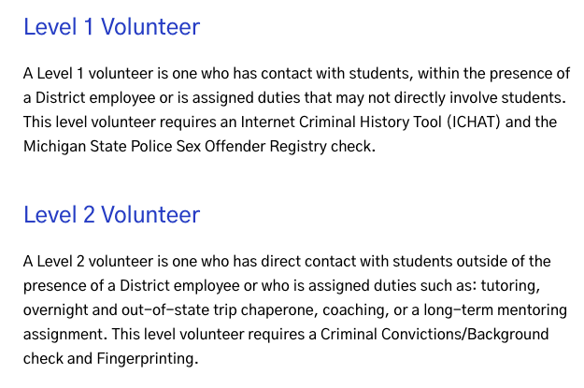

Step 3: Start here: <https://dpscd.galaxydigital.com/user/register/> and follow the steps on the page.

Be sure to select Palmer Park Prep as the school of choice:

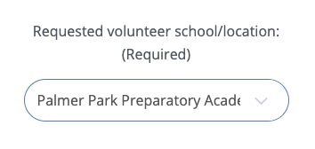

Step 5 will ask you to upload a picture of your ID - this is required every year as a volunteer:

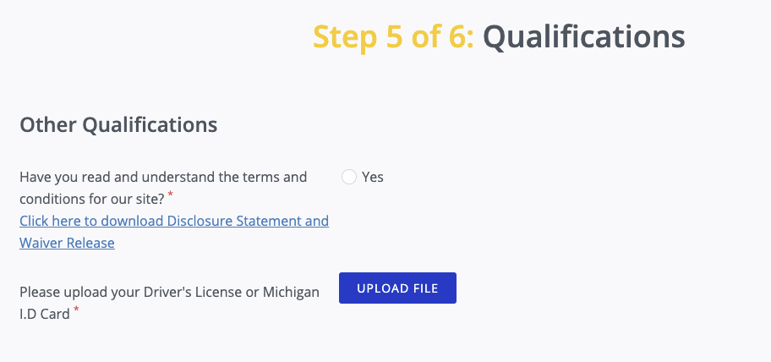

**Renewing an EXISTING volunteer application:**

Three easy steps to get this done:

1. Log-in to your Galaxy Digital Account - [link here](https://dpscd.galaxydigital.com/)
2. Select "Qualifications" at the top of your Dashboard homepage
3. Look for option that says "Upload File" - this where you want to upload a picture of your Driver's License or State ID

When you are going through these steps, it should look like this:

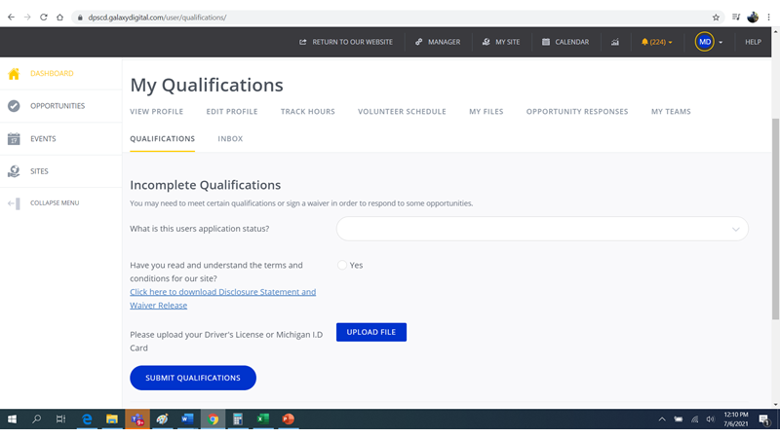

# Meeting Glossary

There are a lot of different meetings that happen in the district and it’s hard to tell which meetings to attend. Please use this section to get a high-level overview of different types of meetings so you can make the best decision on what is worth your time.

**District Meetings**

* **School Board Meetings**
  + School board meetings happen monthly and are held both virtually and in person. Typically there is special recognition, financial reports, superintendent reports, previews of upcoming projects/plans, and finally room for 3 minute public comment. [Board meeting schedules, recaps and notes can be found here](https://www.detroitk12.org/Page/7145).
    - Note: virtual public comments need to be registered at the beginning of the meeting, you cannot join at the end and give virtual public comment.
    - Also - [Detroit documenters](https://detroit.documenters.org/) recaps every school board meeting on twitter and in written notes.
* **Parent Listening Sessions**
  + A more intimate session, usually with Dr. Vitti and 1-2 board members. Dr. Vitti gives an update on various things, then a monitored Q&A happens. This is typically more casual than a board meeting - no Robert’s rules, but it is moderated by DPSCD staff (in other words, not an open forum).
    - The schedule is usually posted on the [FACE (Family and Community Engagement) page on the district’s website](https://www.detroitk12.org/face). The sessions are usually virtual and can be accessd via this link: [bit.ly/ParentListeningSession](https://teams.microsoft.com/l/meetup-join/19%3ameeting_NjBjZDA3NzEtMmVhZS00NDBlLTk5ZDAtNGFhMmY4YjczNDRh%40thread.v2/0?context=%7b%22Tid%22%3a%222ea2d0dc-889d-42bc-9b4c-30271f82e335%22%2c%22Oid%22%3a%229f518b81-4cdc-4acb-9527-11cdb29a6539%22%7d)
* **Parent Academy**
  + [Parent Academy](https://www.detroitk12.org/resources/parents/parent_academy) is another part of the FACE department and features a variety of classes that focus on three key pillars: Student Achievement, Personal and Professional Development, and Parenting/Advocacy.
  + There are so many classes/meetings in [Parent Academy](https://www.detroitk12.org/resources/parents/parent_academy) - definitely check the catalog regularly to see what is coming up. The catalog can be accessed virtually from the Parent Academy webpage. Printed copies are also available at the school.

**Palmer Park Meetings**

* **PTA Meetings**
  + PTA meetings take place on the 3rd Tuesday of every month and rotate in person and virtual for the 2022-23 school year:
    - In person meetings - 4:30pm at the school - September, November, January, March, May
    - Virtual meetings - 6pm via teams - October, December, February, April, June
  + PTA meetings are a great way to stay informed and involved in school happenings and we encourage all parents and teachers to attend! Join the [Facebook group](https://www.facebook.com/groups/356998825226937) or keep your eyes on Class Dojo for meeting invites.
* **Collaborative Conversations**
  + On the first Monday of every month from 4:30-5:30pm - join Principal Reeves (or AP Teasely) in a collaborative conversation where we will have a purposeful, outcome-driven conversation aimed at building on each other's ideas. This will generate new thinking and/or a more in-depth understanding of a desired outcome, e.g. a solution to a problem. Invite found on our facebook group.
* **Open Houses/Orientations**
  + These are typically geared toward new families, or anyone who wants a more intimate look at the school outside of regular school hours. Orientations typically happen before the school year begins and are best for new families. Open Houses can happen 1-2x/year and are great for anyone who may want to learn more about curriculum, schedules, or have a chance to connect with teachers and staff outside of school hours.
* **Parent/Teacher conferences**
  + These occur 2x/year - usually at the beginning of the school year and again in the spring. This is a great chance to have 1:1 conversations with your teacher about your student.

**Montessori program meetings**

* **Detroit Public Montessori Community Meetings**
  + These meetings are promoted on the [Detroit Public Montessori](https://www.facebook.com/groups/1745953765677718) page and contain updates from district montessori and parent leadership and updates from the three schools in the DPSCD montessori program. They are typically held virtually.

# Montessori Specific Details

## ​​**Birthdays:**

* In a Montessori classroom, we celebrate by counting how many years a child has “traveled around the sun”. This is an opportunity for us to practice the months, talking about space mechanics, and celebrate your child. A few weeks before your child’s birthday, you will receive a message from me asking for pictures or stories about your child. I will share these with the class when we celebrate.
* You may bring in a treat to share with the class. Please bring a healthy, prepackaged snack (think applesauce pouches or mini oranges) or a non-edible “treat” (think temporary tattoos or pencils). Please do not send cupcakes or other desserts.

## Work Time:

Work Time is an important block of time in a child’s day. During Work Time your child is independently choosing their own work and lessons to complete. As the year progresses, Work Time will take up most of the morning. During this time, the teacher is observing students, giving independent lessons, and giving small group lessons.

## Cubbies/Lockers:

Your child will have a labled cubby or locker outside their classroom for coats, backpacks, shoes, etc. Please label all items and clothing you send to school with your child. Locks are not needed for lockers

## School Shoes:

Please send an extra pair of shoes to school with your child to be worn only in the classroom. These do not need to be new shoes! Your child will change into their school shoes to come into the classroom and back into their shoes/boots to go outside. This helps keep our floors clean, which is where Montessori students place their mats to work.

## Outdoor Time:

All students go outside 1-2x every day as long as the weather is safe. Please send your child to school with appropriate outdoor clothing every day.

## First day/week things needed:

* Blanket and (optional) fitted crib sheet (Pre-K only)
* Crocs/soft indoor shoes
* Folder
* Change of clothes in a labeled plastic zip lock bag (Optional. Does not have to be a uniform. Heavily encouraged for Pre-K/K, but encouraged for all kids as the playground can get muddy and accidents/spills can happen to anyone)
* School supplies are provided for your child. Your teacher may request additional items directly during the first week or throughout the school year.

## Pre-K/K specifics

**Rest time:**

Preschool students will have a quiet rest time every afternoon. Please send a blanket (and a fitted crib sheets, if you would like) with your child. These will be kept at school all week and sent home to be washed on Fridays. We will provide a fitted sheet for the rest cots if you do not.

Kindergarten students will not take a rest, but will have quiet work time or I Ready time.

​​