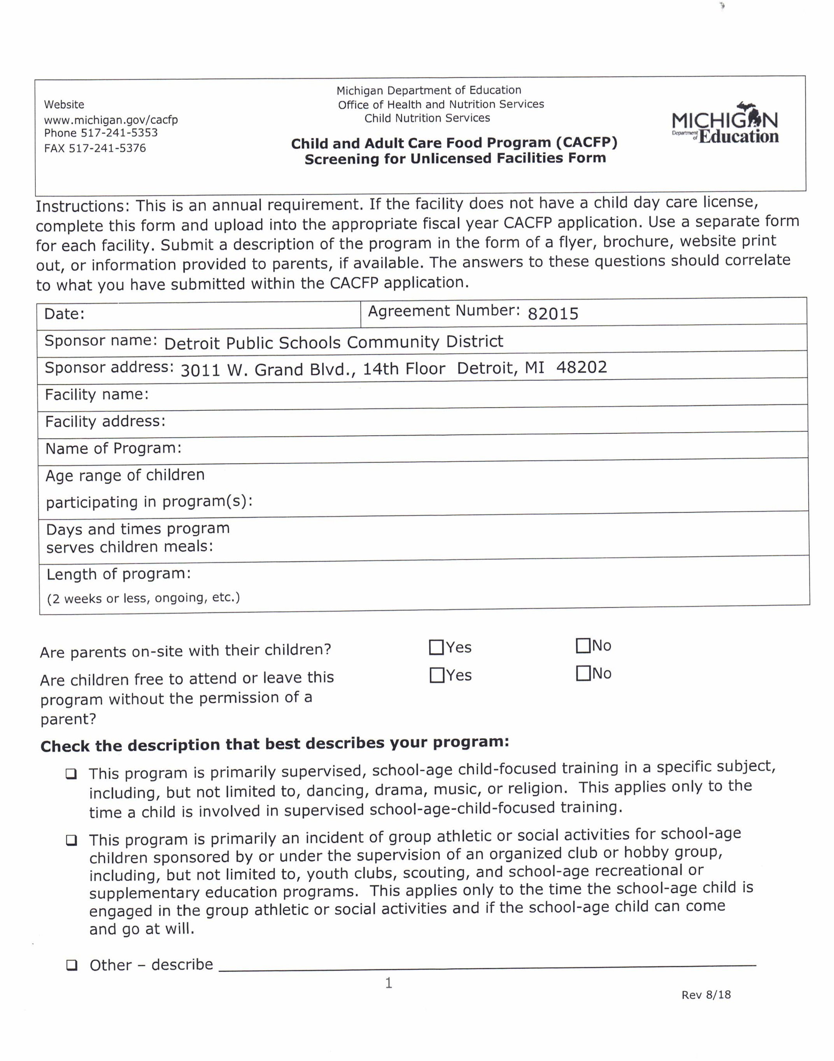

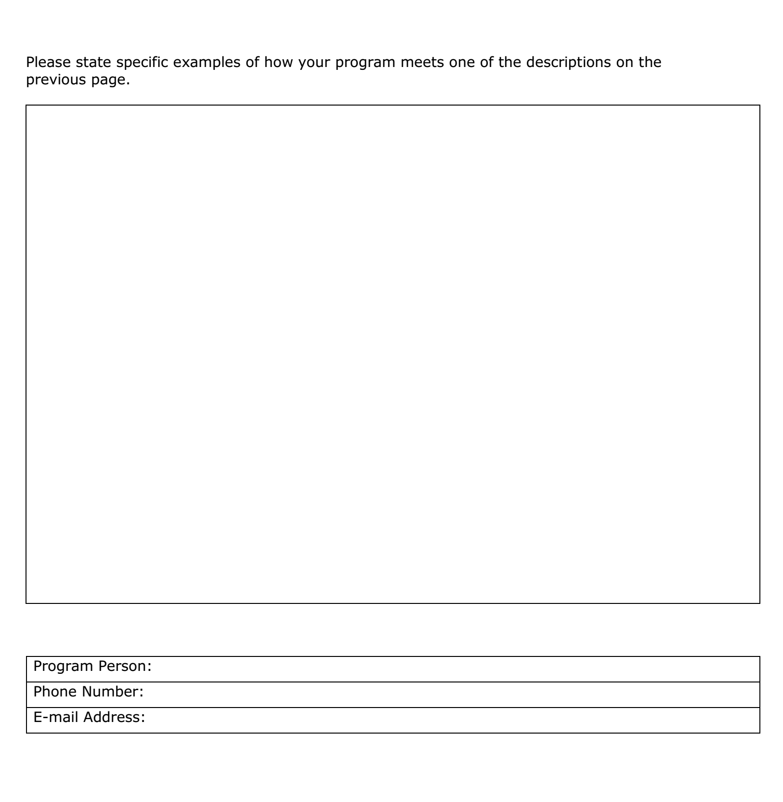

**SUPPER PROGRAM FORM 25-26 SY**

School Name____________________________

1. Start date of program: _______________________
2. End date of program: ________________________
3. Days of the week for the program: (circle) M T W TH F S

1. Program starting time: __________________
2. Program end time: _____________________
3. Anticipated number of students enrolling in the program: ____________

Principal Signature: ___________________ Date: ______________

**Please email your completed form to** [**yuwana.trice@detroitk12.org**](mailto:yuwana.trice@detroitk12.org)

**Student Daily Attendance Roster by Week**

School Name: _______________________ Week Ending Date: ___________________

Program/Activity Name: _ _____________________

|  |  |  |  |  |  |  |  |
| --- | --- | --- | --- | --- | --- | --- | --- |
| # | Student Name | Mon | TUE | WED | THU | FRI | SAT |
| 1 |  |  |  |  |  |  |  |
| 2 |  |  |  |  |  |  |  |
| 3 |  |  |  |  |  |  |  |
| 4 |  |  |  |  |  |  |  |
| 5 |  |  |  |  |  |  |  |
| 6 |  |  |  |  |  |  |  |
| 7 |  |  |  |  |  |  |  |
| 8 |  |  |  |  |  |  |  |
| 9 |  |  |  |  |  |  |  |
| 10 |  |  |  |  |  |  |  |
| 11 |  |  |  |  |  |  |  |
| 12 |  |  |  |  |  |  |  |
| 13 |  |  |  |  |  |  |  |
| 14 |  |  |  |  |  |  |  |
| 15 |  |  |  |  |  |  |  |
| 16 |  |  |  |  |  |  |  |
| 17 |  |  |  |  |  |  |  |
| 18 |  |  |  |  |  |  |  |
| 19 |  |  |  |  |  |  |  |
| 20 |  |  |  |  |  |  |  |
| 21 |  |  |  |  |  |  |  |
| 22 |  |  |  |  |  |  |  |
| 23 |  |  |  |  |  |  |  |
| 24 |  |  |  |  |  |  |  |
| 25 |  |  |  |  |  |  |  |
| 26 |  |  |  |  |  |  |  |
| 27 |  |  |  |  |  |  |  |
| 28 |  |  |  |  |  |  |  |
| 29 |  |  |  |  |  |  |  |
| 30 |  |  |  |  |  |  |  |