From the front page of the HUB select “Submit a Ticket for Support”.

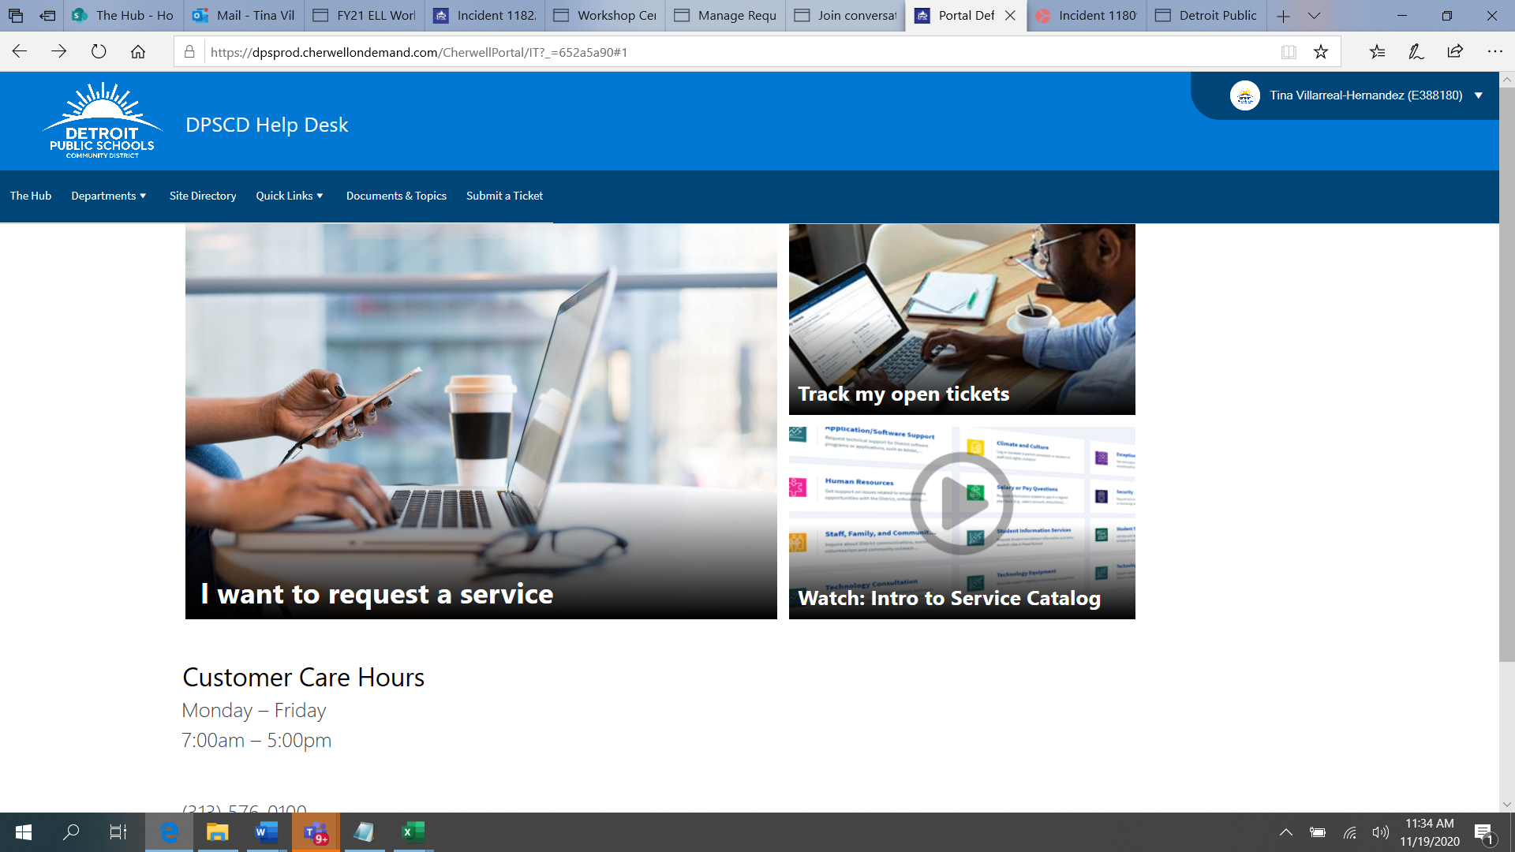

Select “I want to request a service”.

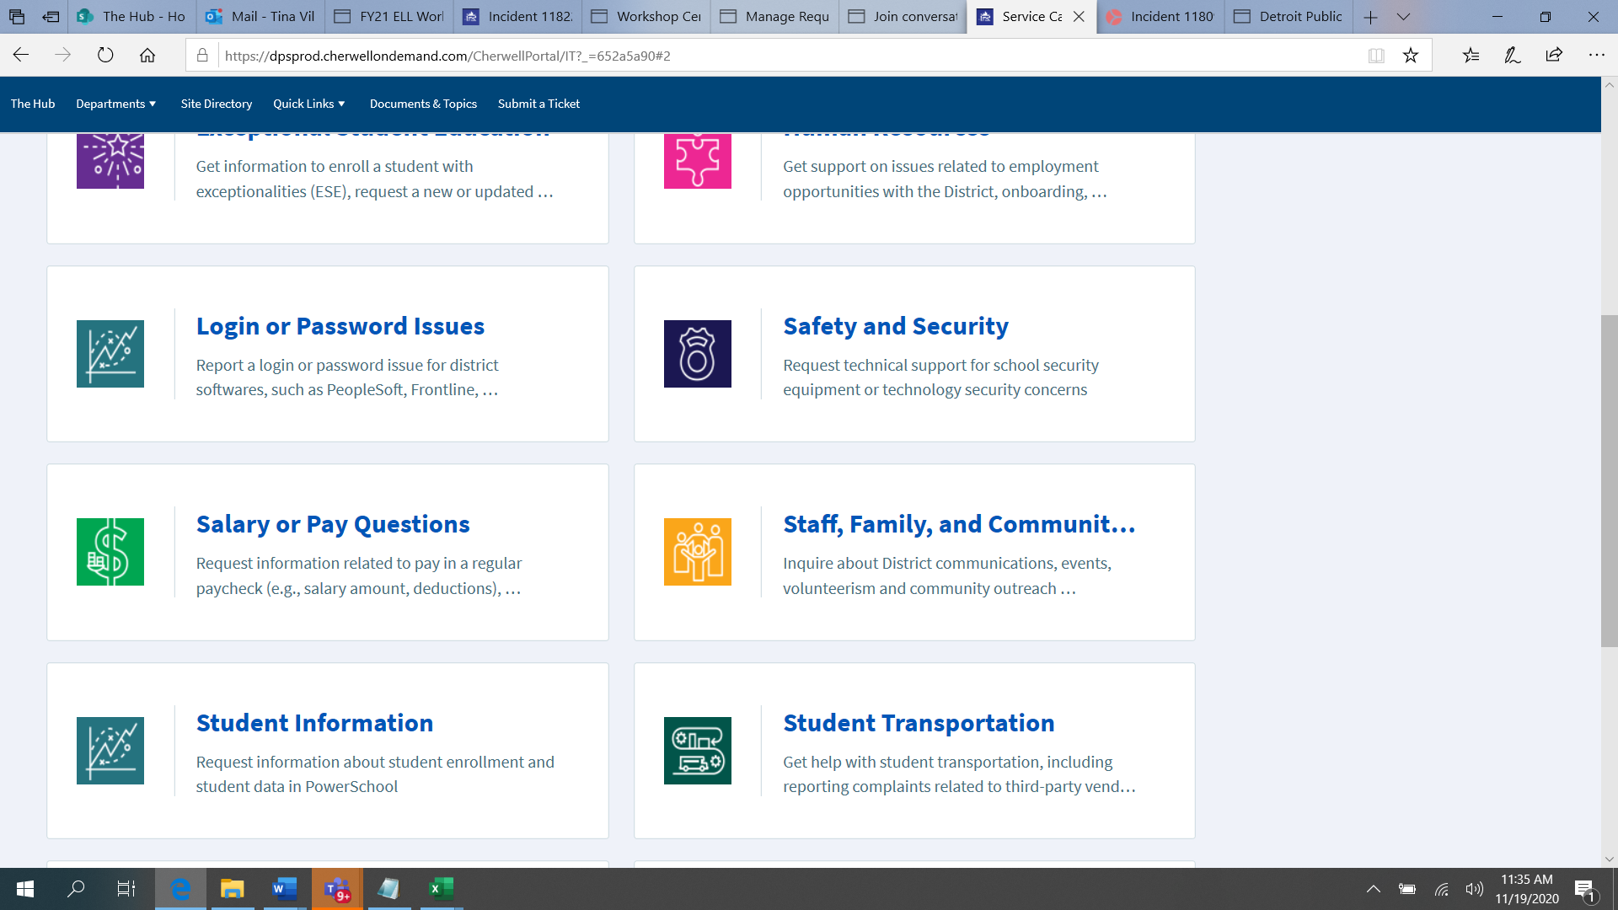

Select “Staff, Family and Community Engagement”

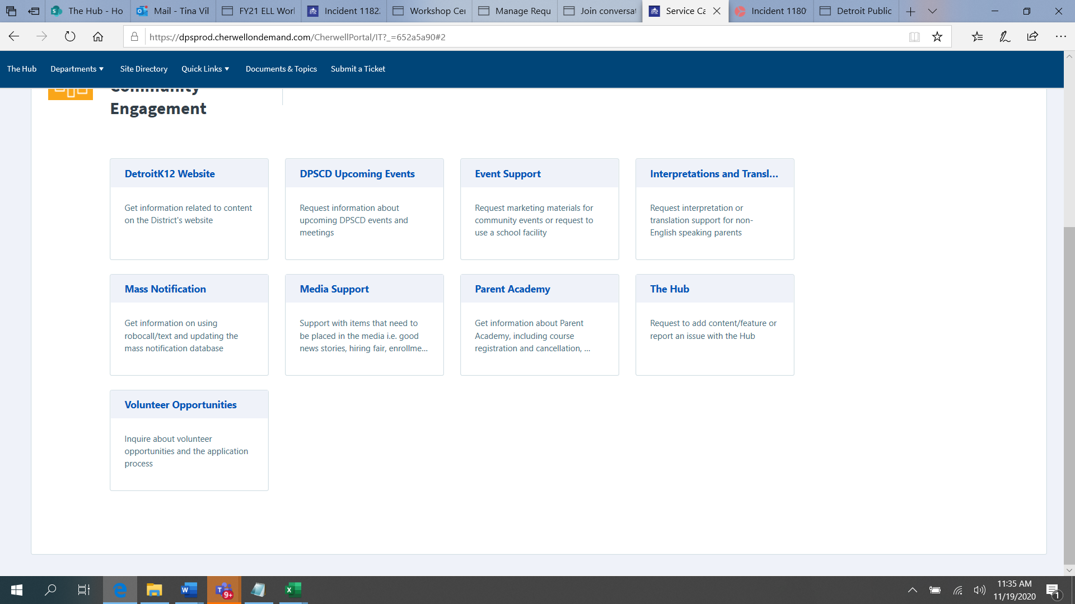

Select “Interpretations and Translations”

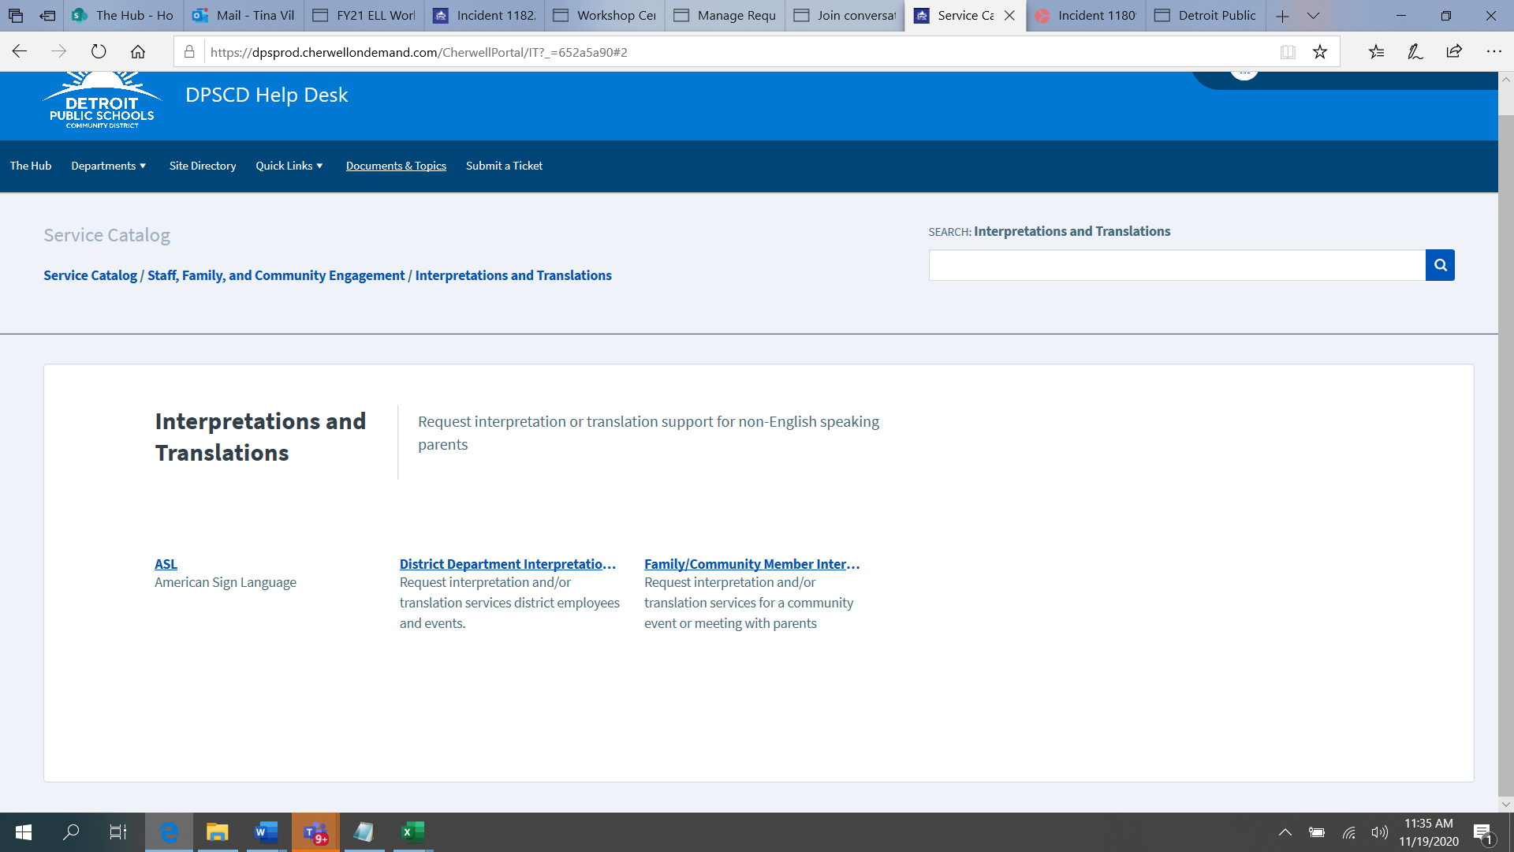

Select “Family/Community Members Interpretations or Translations”.

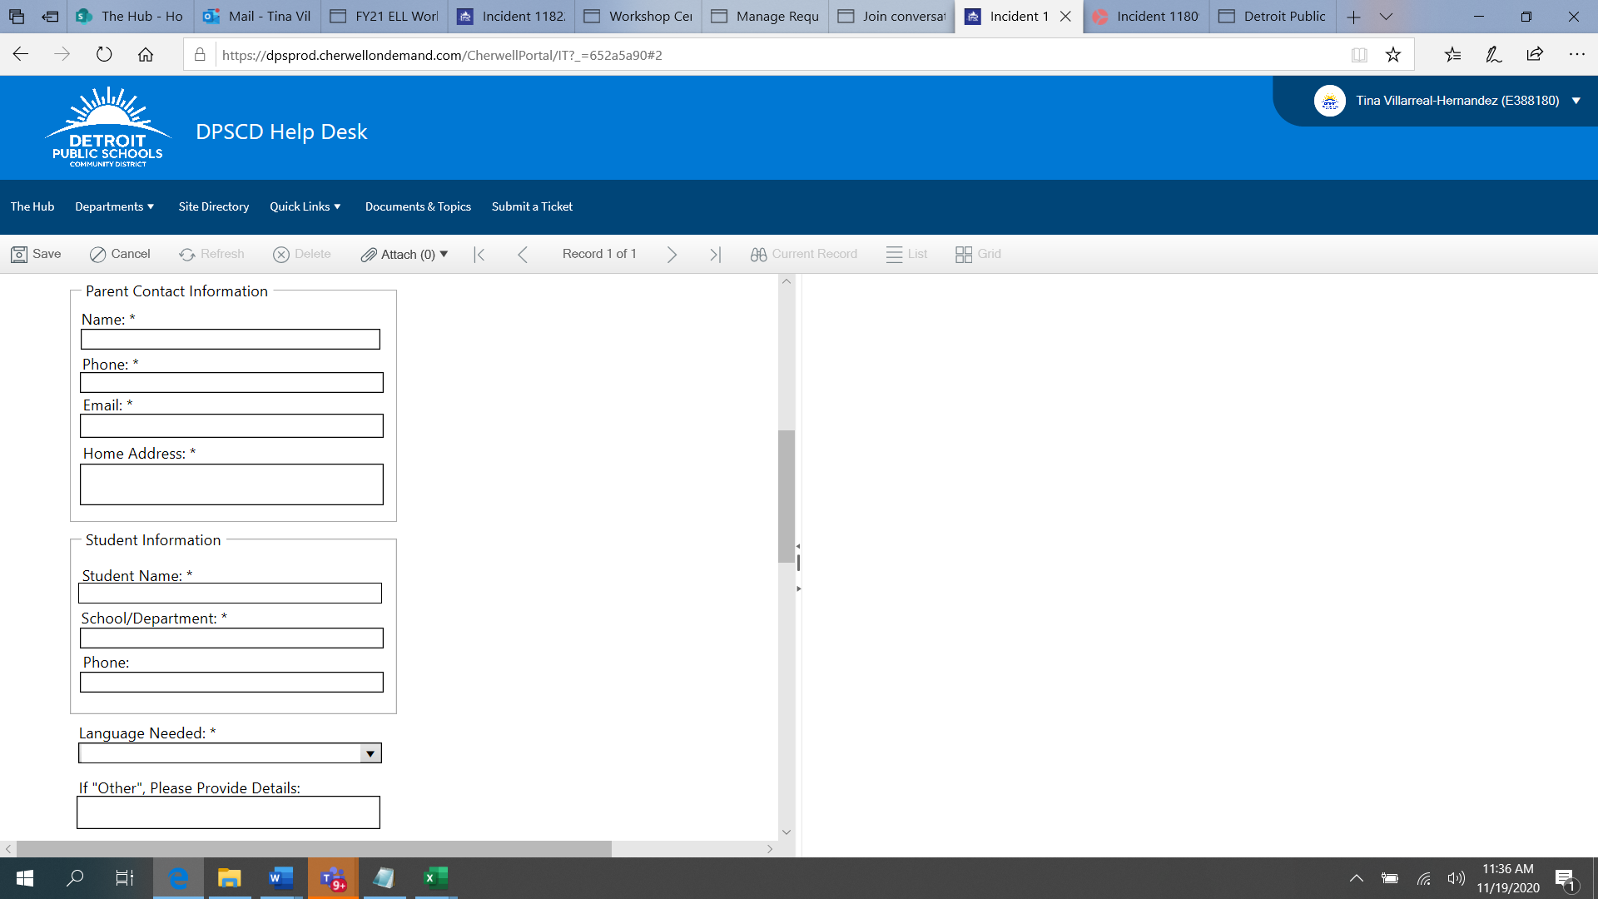

Fill out all pertinent information. If every field is not populated, you will receive an “error message” and the system will NOT allow you to create a ticket.

For Translations, you may “Attach” the document to the ticket under “Attach”. (please see the “red” arrow above.

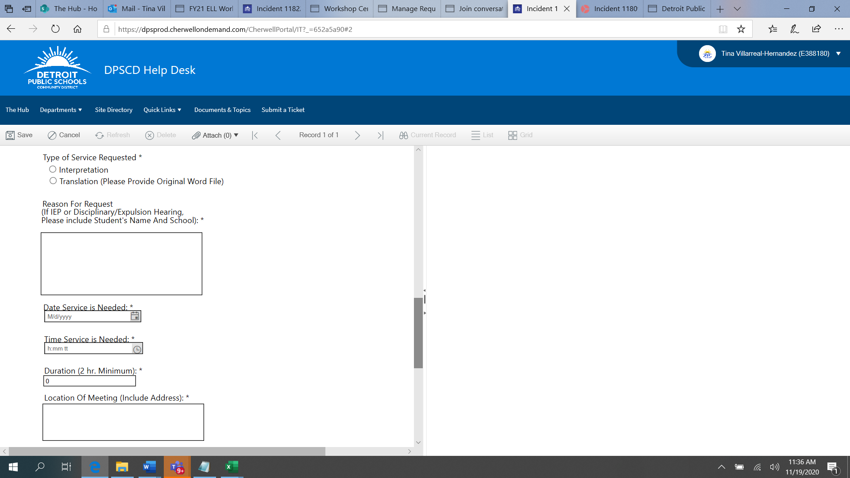

Please be sure to include all information pertinent to the meeting. Including the Virtual Meeting Link, you may put that in the “Location” area. It is important to CREATE the TEAMS meeting BEFORE requesting an interpreter. We can not request an interpreter without all the appropriate information necessary for the meeting to take place.